GAME DESIGN DOCUMENT

Name of the Game: Need More Speed

Overview: Need More Speed is an Arcade racing game for PC that revolves around night street racing scene and AI racers behaviour implemented using Machine Learning. The cars that player drives and races against are Remote controlled which are being driven on a tracks made on real roads. The player needs to race on different tracks and difficulty modes to unlock more cars and tracks. Radio stations will be playing modern Hip-Hop and EDM music.

Along with track racing in Need More Speed :

* Player has an option to free-roam in large open areas, downhill drives and many more.
* The low poly art style of the game and unity game engine will be a really blend for this game.
* The cars will have the arcade type handling model rather than realistic to give the illusion of a remote controlled car.
* The story of game in short revolves around a group of RC car enthusiasts looking to make remote controlled car racing an official sport.

Tools Used:

Unity 2021.2.10f1 , ML-Agents, Adobe PhotoShop

Game Mechanics:

* New cars can be unlocked only through drop boxes, in which the probability of getting cars will be arranged according to the rarity of the vehicle.
* Pickups in races will provide some power-ups if picked up, will give some advantage to the one who picked it over the rivals.
* Winning a race has a chance to give either a car crate or an upgrade part which can be used to improve performance of current car.
* Has a feature to create your own car where the player has the ability to merge multiple cars to make their own customized ride.
* AI trained using Imitation and Reinforcement learning will provide a real player like behaviour when racing against NPC’s.
* Give the ability to customize the ride according to the activity that the player wants to be engaged in. Some of these are:

-Street Builds: these will provide better cornering abilities.

-Racing Builds: These will provide better speeds.

-Drag Builds: Best for short, straight tracks.

-Drift Builds: Best suited for drift tracks.

Gameplay Loop:

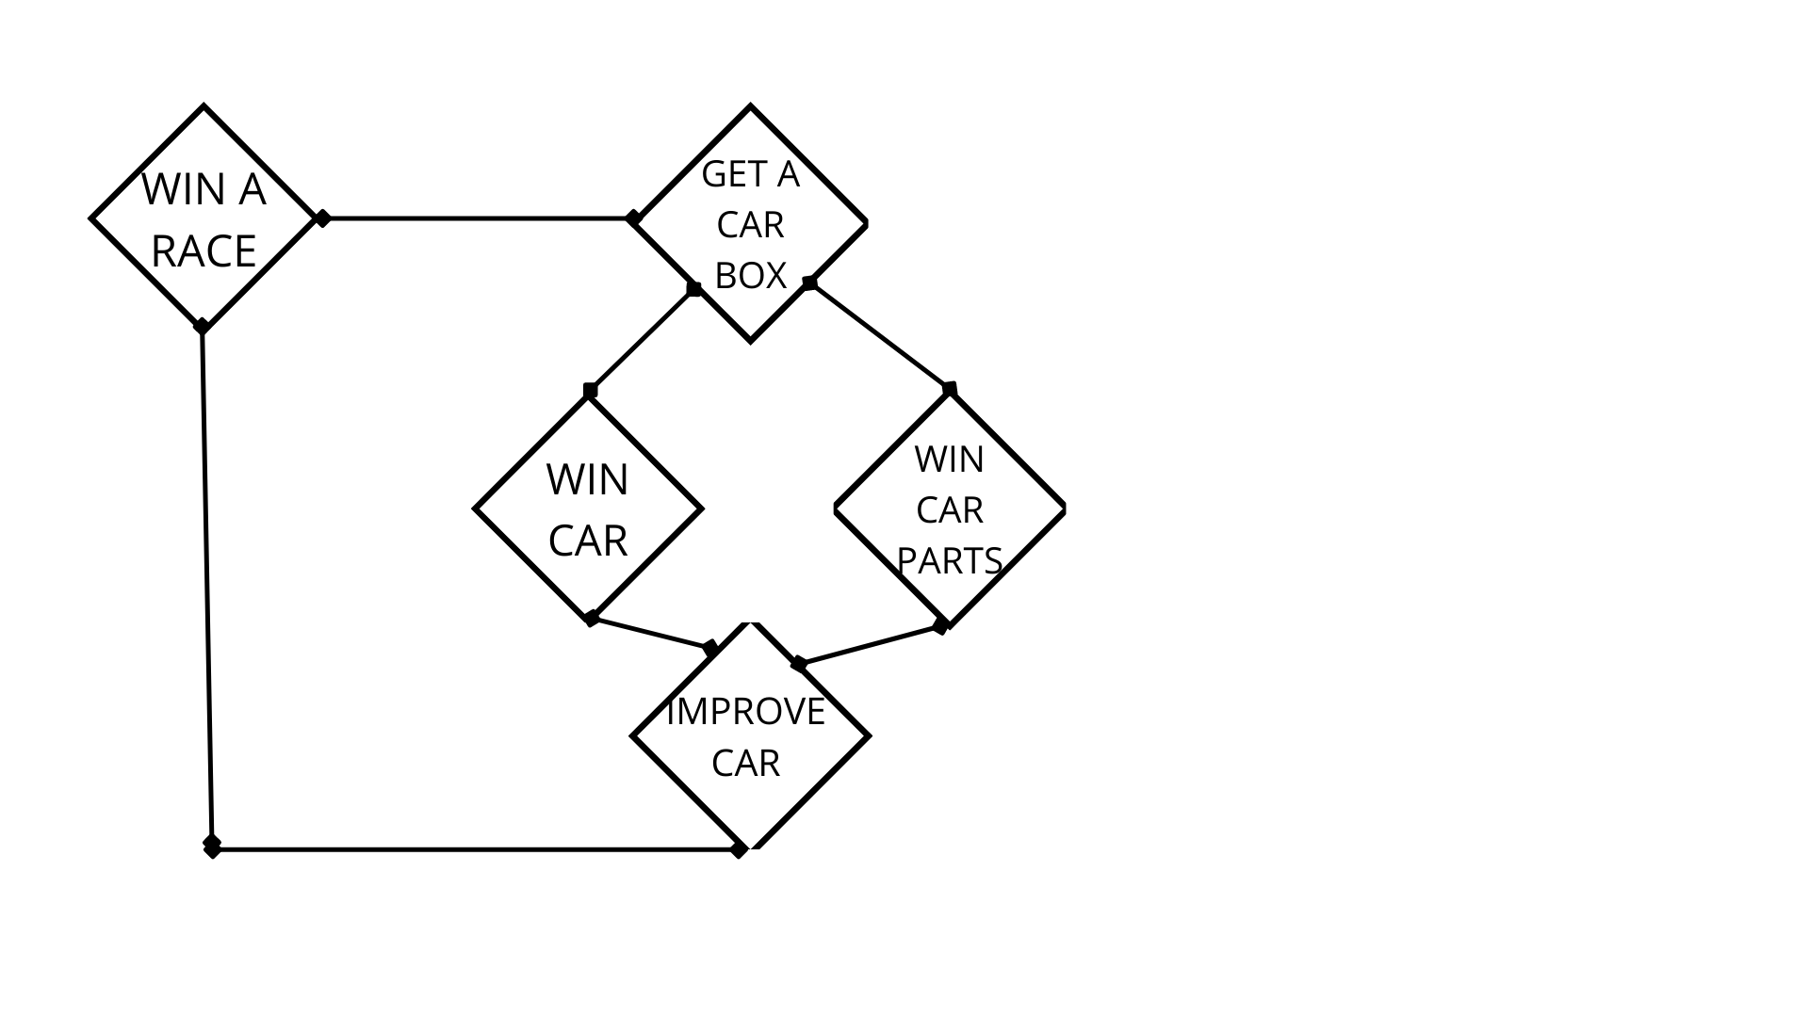

Challenges:

Need more speed can be played in three difficulty modes, higher difficulty gives better rewards for winning.

The higher level the player goes up, the more difficult rival drivers will he race against.

Platforms:

PC(Windows)

Monetization Model:

The car packs that give cars and upgrade parts to improve performance can either be bought from the game store or won by winning races.

Additionally a car pass can be added to the game, if purchased, will give unique cars and customization options to the player. Car pass will have have a linear progression system which will increase pass level for completing small daily and weekly goals, each level gained in pass will give one reward.

Demographics:

Need More Speed is targeting players who enjoy casual racing games.

***ESRB Rating***

ESRB-E

Sound and Licensing:

The music and sound effects used in the game is Licensed from Monstercat Merlin, NCS and Epidemic Sound.

Art Style and Mood-board:

